Institute of Management Sciences hosted a two day Meeting
Regarding Establishment of KP Joint Research Forum of ORIC in Khyber Pakhtunkhwa
Institute of Management Sciences Peshawar held a two day meeting regarding establishment of Joint Research Forum of ORIC in Khyber Pakhtunkhwa. Dr. Muhammad Mohsin Khan, Director, Institute of Management Sciences Peshawar hosted the meeting of Director ORIC from all Public Sector Universities in KP to discuss collective issues faced by ORIC Offices.
Dr. Muhammad Mohsin Khan warmly welcomed the participants of the meeting and ensured the support of his institute to all the ORIC Offices in KP.
Areas of common interest were identified and opportunities for coordination among ORIC Offices at Public Sector Universities of the Province were discussed. Representatives of Federal and Provincial Governments also attended the meeting and updated the participants regarding initiatives under taken by respective Governments for the universities. Various case studies were presented by Mr. Rehmat of Institute of Research Promotion regarding issues faced by the industry and probable areas of interventions for the ORIC KP.
Mr. Mohsin Ali Syed, CEO, Khyber Pakhtunkhwa Economic Zones development presented the policies of the Provincial Government regarding the development of Economic Zones and business opportunities of the future in KP which was a valuable input for ORIC planning its future strategy in the context of CPEC.
The initiative of Institute of Management Sciences was appreciated across the board and that it will equally benefit all the academic institutions of the Province.
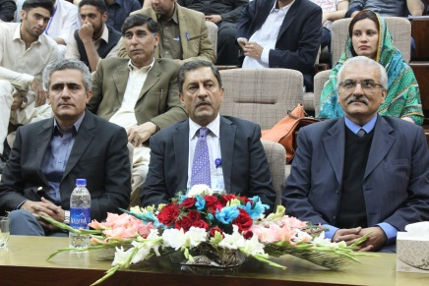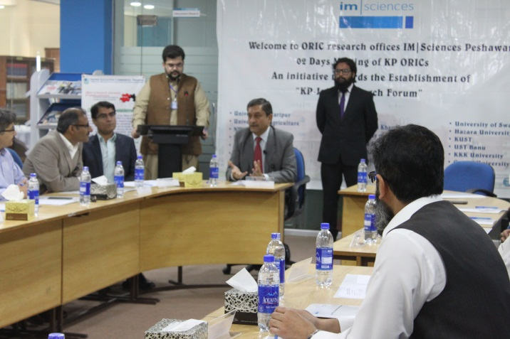

Following participants attended the meeting:
1 | Dr. Mohammad Nisar | Director ORIC | University of Peshawar.
2 | Dr.MuhammadJhangir | Director ORIC | University of Haripur,
3 | Mr. ArbabSafeer Ahmad Khan, | Director ORIC | Islamia College University,
4 | Miss Sana | Research Officer | Shaheed Benazir Bhutto Women University,
5 | Ms. Faiza Malik | Deputy Director ORIC | Abdul Wali Khan University
6 | Dr. Ajab Khan | Director ORIC | University of Malakand,
7 | Dr. GulShahzada Khan, | Director ORIC | Shaheed Benazir Bhutto University, Sheringal,
8 | Dr. Farman Ali Khan | Additional Director ORIC | Shaheed Benazir Bhutto University, Sheringal,
9 | Professor Dr. ShafiqurRehman | Director ORIC | Kohat University of Science and Technology,
10 | Dr. Mushtaq Ahmad, | Director ORIC | University of Science & Technology, Bannu,
11 | Dr. Muhammad Zubair | Director ORIC | Khushal Khan Khattak University,
12 | Dr. Jamil | Director ORIC | Gomal University,
13 | Mr. RehmatUllah | Chief Coordinator | Institute of Research Promotion
14 | Mr. Istiaq | Chief Planning Officer | ST&IT Department
15 | Madam Ghazala Malik | Deputy Director | PASTIC, Pakistan Forest Institute
16 | Mr. Mohsin Ali Syed | Chief Executive Officer | KPK Economic Zones
17 | Dr. Muhammad Mohsin Khan | Director | Institute of Management Sciences, Peshawar
18 | Dr. Muhammad Ali | Joint Director | Institute of Management Sciences, Peshawar
19 | Dr. Awais Adnan | Coordinator ORIC | Institute of Management Sciences, Peshawar
20 | Mr. Adnan Ameen Khan | Assistant Manager University Industry Linkage | Institute of Management Sciences, Peshawar

