IM|Sciences Signed MoU with Ihsan Trust

A delegation of high level officials from Ihsan Trust and Meezan Bank visited Institute of Management Sciences Peshawar on 14th May, 2015. The delegation consisted of Mr. Fayyaz Ur Rehman, Vice President, Product Development & Shariah Compliance (PDSC), Meezan Bank Ltd., Mr. Zulqarnain Haider, Assistant Manager, Product Development & Shariah Compliance (PDSC), Meezan Bank Ltd., Mr. Khwaja Javid, Area Manager Peshawar, Mr. Mian Fawad Shah, Branch Manager Hayatabad. The senior management of IM|Sciences welcomed the delegation and assisted them by sharing information on IM|Sciences fundraising mechanism, grants management, outreach and communication and scholarship programs. Grants Office, IMSciences informed them about the 43 different financial aid / scholarship programs, amounting Rs. 182 Million, in the form of need-and-merit based scholarships, interest free student loans, siblings-fee-rebate, work study and global cultural exchange programs.

Mr. Fayyaz Ur Rehman, Vice President, Product Development & Shariah Compliance (PDSC), Meezan Bank Ltd. And Dr. Muhammad Mohsin Khan, Director Institute of Management Sciences Peshawar and Dr. Muhammad Ali, Joint Director, Institute of Management Sciences, Peshawar signed on the Memorandum of Understanding. Through this MoU, Ihsan Trust will provide financial support of amounting Rs. 4 Million / Year for Four (04) years in the form of interest free loan to students of Institute of Management Sciences Peshawar. Ihsan Trust authorities extended their full support and cooperation to Institute of Management Sciences Peshawar in different areas of seminars, research and studies, especially in Islamic Banking and Finance.
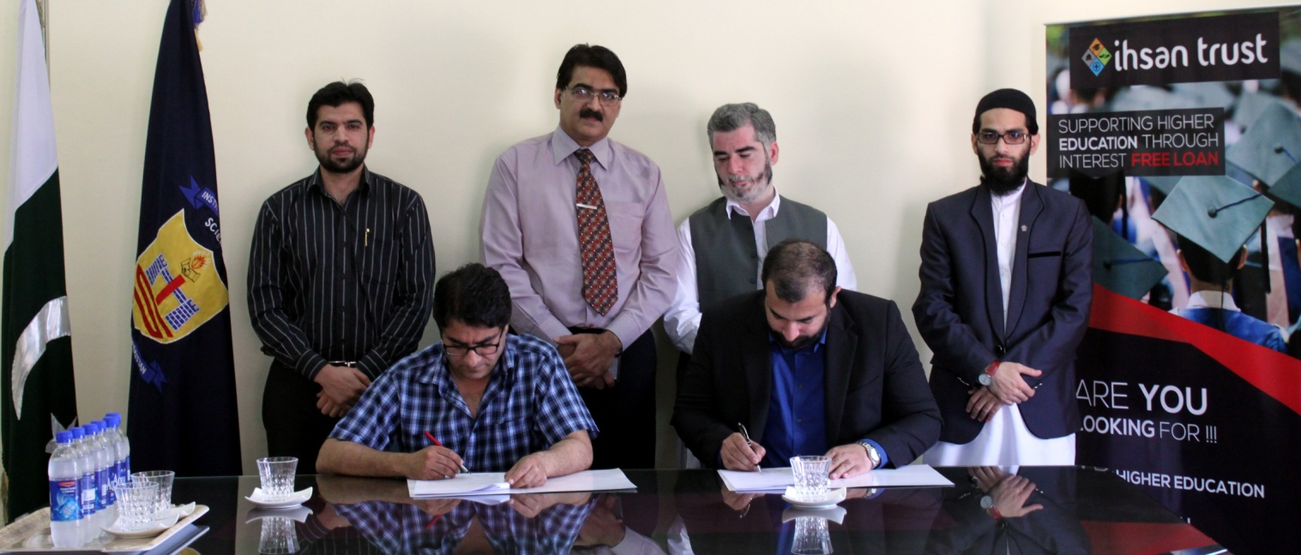

Dr. Muhammad Ali, Joint Director Institute of Management Sciences, Peshawar and Mr. Fayyaz Ur Rehman, Vice President, Product Development & Shariah Compliance (PDSC), Meezan Bank Ltd. Signing MoU of Rs. 4 Million
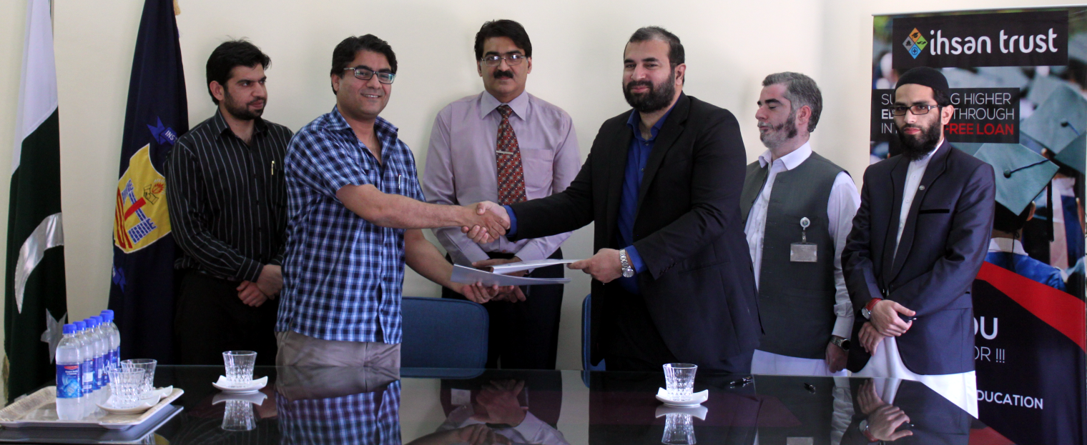

Dr. Muhammad Ali, Joint Director Institute of Management Sciences, Peshawar and Mr. Fayyaz Ur Rehman, Vice President, Product Development & Shariah Compliance (PDSC), Meezan Bank Ltd. Sharing MoU of Rs. 4 Million

